**ANALYSIS REPORT**

**- Bhavana Ravipati**

**Dataset:** [**Dataset Link**](https://kingcounty.gov/depts/transportation/metro/travel-options/bus/app-center/developer-resources.aspx)

King County is served by three transit agencies, the City of Seattle, Metro Transit, and Sound Transit. The data available spans January to June of 2023. Given that it is currently February of 2023, this appears to be proposed information for planning public transit services to the county. A dashboard tool for visualizing the breadth and depth of service coverage is needed to evaluate adequate service coverage and the distribution of agency demand is needed on a real-time basis.

Based on the information provided in the data files, we can gain several decision-making insights about mass transit operations in King County, Washington:

* The volume of Routes, across 25 Zones, by day of the week.
* The Number of Trips within each route, by Zone, and by day of the week.
* The date range filter to observe seasonality in travel patterns over time.
* Slicing and dicing across Zones and Stop Stations gives us visibility into peak demand and availability of supply.
* Optimizing the pricing based on the above-mentioned KPIs would lead to an incremental impact on Revenue.

Here, is the Dashboard Summary Analysis:

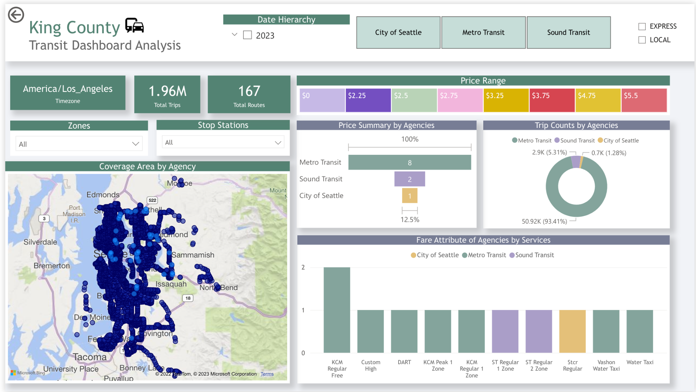

**Drill Down Details:**

1. Coverage frequency across Stops
2. Summing the number of trips per stop
3. Analysis of KPIs (Number of Trips, Number of Routes, Stops, service by Zone, by Agency, by Local/Express, by Day of the Week, and filtered by Date period)
4. A coverage percentage of Trips by Agency

These insights help leaders to make informed decisions about travel options, understand the popularity of different stops and routes, and compare the services and prices offered by different agencies.

**Further Analysis On Dataset**

* **Service Information:** What are the different transit agencies operating in King County and what services do they offer?
* **Fare Information:** What are the fares offered by each public transit agency? How do they vary based on payment methods, transfers, and other factors?
* **Route Information:** What are the different bus routes in the transit system and what is the geographical shape of each route?
* **Stop Information:** What are the different stops along the public transit system and what is the schedule for each stop?
* **Trip Information:** What are the different trips offered by each transit agency and what is the information about each trip?

There are a few possible reasons why each transit agency has the values that were observed in the King County Transit Dashboard analysis:

* **Service offerings:** The transit agencies may have different service offerings based on their respective areas of coverage and the needs of the communities they serve. For example, the City of Seattle may only offer one type of service because it operates within a limited area, while Metro Transit and Sound Transit offer a wider range of services to cover a larger region.
* **Price range:** The price range may reflect the costs of providing the different services, as well as the level of government subsidies that each agency receives. For example, the City of Seattle may charge a lower fare for its Strc Regular service because it only covers a limited area and is heavily subsidized by the local government, while Sound Transit may charge a higher fare for its express service because it covers a wider area and requires more resources to operate.
* **Trip counts:** The number of trip counts may be influenced by a variety of factors, such as population density, demographics, time of day, and day of the week. For example, Metro Transit may have higher trip counts because it operates a wider range of services and covers a larger area, while Sound Transit may have lower trip counts because it primarily serves commuters during peak hours.
* **Travel offerings:** The different travel offerings may reflect the needs and preferences of the communities that each agency serves. For example, the City of Seattle may offer only local travel because it primarily serves residents of the city, while Sound Transit may offer only express travel because it primarily serves commuters who travel long distances.

**Detailed Dataset Analysis:**

| **Files Analysis for Dashboard** | |
| --- | --- |
| **agency.txt** | The data in the file "agency.txt" pertains to different transit agencies operating in King County, Washington state.  The information provided in the file includes the agency ID, agency name, agency URL, agency time zone, agency language, agency phone number, and agency fare URL. There are three transit agencies in the file, namely Sound Transit, Metro Transit, and City of Seattle. |
| **calendar_dates.txt** | service_id: This field is likely an identifier for a specific service or component of a system. The value of this field may be used to distinguish between different services or components in the file.  date: This field is likely a date and time stamp indicating when an event or exception occurred.  exception_type: This field is likely a code or description of the type of exception that occurred. It may be used to categorize or classify exceptions in the file. |
| **calendar.txt** | The date format in this file seems to be in the format of "YYYYMMDD". For example, the date "20230123" represents January 23rd, 2023. |
| **fare_attributes.txt** | The data in the file "fare_attributes.txt" appears to be information about different fares offered by a public transit agency. Each row in the file represents a different fare and contains the following fields:  fare_id: a unique identifier for each fare.  agency_id: the identifier for the transit agency offering the fare.  fare_period_id: the identifier for the fare period during which the fare is in effect.  price: the price of the fare in US dollars.  descriptions: a brief description of the fare.  currency type: the type of currency the fare is priced in (here, it is always USD)  payment_method: the method of payment for the fare (e.g., cash, credit card, etc.)  transfers: the number of transfers included in the fare.  transfer_duration: the duration of time, in seconds, during which transfers are valid. |
| **fare_rules.txt** | These are fare rule data in a transportation context. The file is named "fare_rules.txt". The data in this file defines the relationships between fares and routes, origins, and destinations. The columns in the data are:  fare_id: A unique identifier for a fare  route_id: A unique identifier for a route  origin_id: A unique identifier for an origin location  destination_id: A unique identifier for a destination location  contains_id: A unique identifier for a contained location (this column is empty in most of the rows)  This information is used by the transportation system to determine which fare to charge for a given trip based on the origin, destination, and route information. |
| **route.txt** | These data represent information about different bus routes in a transit system. The data includes the following fields:  route_id: A unique identifier for the bus route  agency_id: An identifier for the agency operating the bus route.  route_short_name: A short name for the bus route  route_long_name: A longer name for the bus route.  route_desc: A description of the bus route  route_type: The type of route (e.g., local, express, etc.)  route_url: A URL with more information about the bus route  route_color: The color assigned to the bus route.  route_text_color: The color used for text associated with the bus route |
| **shapes.txt** | These data are geographic shape points of a public transit route, in the format of shape_id, shape_pt_lat, shape_pt_lon, shape_pt_sequence, shape_dist_traveled. The shape_id refers to a unique identifier of the route. The shape_pt_lat and shape_pt_lon represent the latitude and longitude of a point on the route, and the shape_pt_sequence represents the order of the points in the route. The shape_dist_traveled is the accumulated distance traveled along the route from its starting point. The file name, shapes.txt, suggests that it contains information about the shapes of transit routes. |
| **stop_times.txt** | The data in "stop_times.txt" file represent the schedule for a single trip ( identified by the "trip_id" field), including the arrival and departure times at each stop along the trip. The stops are ordered by stop sequence, which determines the order that the stops are visited by the trip. For each stop, the data contains information such as stop ID, stop sequence, headsign, pickup type, drop off type, shape distance traveled, and timepoint. |
| **stops.txt** | These data are information about different stops along a public transit system. The columns in the data file "stops.txt" include:  stop_id: a unique identifier for each stop.  stop_code: a short code for each stop.  stop_name: the name of the stop.  stop_desc: a description of the stop.  stop_lat: the latitude of the stop.  stop_lon: the longitude of the stop.  zone_id: the identifier of the fare zone the stop belongs to  stop_url: a URL with additional information about the stop.  location_type: the type of location represented by the stop.  parent_station: the identifier of the parent station of the stop, if applicable  stop_timezone: the time zone in which the stop is located. |
| **trips.txt** | These data represent information about the trips taken by public transportation vehicles, such as buses or trains. The data contains the following columns:  route_id: A unique identifier for the route the trip is running on.  service_id: A unique identifier for the set of dates the trip is running on.  trip_id: A unique identifier for the trip.  trip_headsign: The text that is displayed to the passengers indicating the direction or final destination of the trip.  trip_short_name: A short version of the trip name, typically used for schedules and signage.  direction_id: The direction of travel of the trip, either 0 or 1.  block_id: A unique identifier for the block of trips, which is a sequence of trips that operate between the same start and end time.  shape_id: A unique identifier for the shape of the trip, which is a path that the trip follows.  peak_flag: A flag indicating whether the trip operates during peak or off-peak hours.  fare_id: A unique identifier for the fare associated with the trip. |